3MTT Darey.io NextGen Cohort
SOFTWARE QUALITY ASSURANCE PROJECT ASSIGNMENT
TOPIC: FOUNDATION OF MANUAL QA (CAPSTONE 1)
Submitted By:
Name: NLIAM STANLEY
Email Address: nliamstanley2018@gmail.com
Date: 10/06/2026

TABLE OF CONTENTS
- Introduction
- Project Overview
- Requirement Analysis
- Test Plan
- Test Cases
- Test Execution Results
- Bug Reports
- Conclusion
INTRODUCTION
Software Quality Assurance (QA) is the process of ensuring that software products meet specified requirements and function correctly before being released to users. This project demonstrates the practical application of Manual QA testing concepts using the SauceDemo web application.
PROJECT OVERVIEW
- Application Name: SauceDemo
- Module Tested: Login Functionality
- Application URL: https://www.saucedemo.com
Objective:
To verify that the login functionality works correctly for valid and invalid user credentials and to identify any defects affecting usability and functionality.
REQUIREMENT ANALYSIS
Th,e login module should satisfy the following requirements:
- Users should be able to log in using valid credentials.
- Invalid credentials should display an error message.
- Username field should be mandatory.
- Password field should be mandatory.
- Locked-out users should not be granted access.
- Successful login should redirect users to the products page.
TEST PLAN
Test Objective
To validate the login functionality of the SauceDemo application.
Scope
Included:
- Login page
- Username validation
- Password validation
- Error messages
- Successful login
Excluded:
- Checkout functionality
- Product purchase process
Test Environment
Browser: Google Chrome Operating System: Windows 10 Application URL: https://www.saucedemo.com
Test Approach
Manual Functional Testing
Entry Criteria
- Application is accessible.
- Test credentials are available.
Exit Criteria
- All planned test cases executed.
- Defects documented.
TEST CASES
TC001
Test Scenario: Login with valid credentials
Test Steps:
- Open SauceDemo website.
- Enter valid username.
- Enter valid password.
- Click Login.
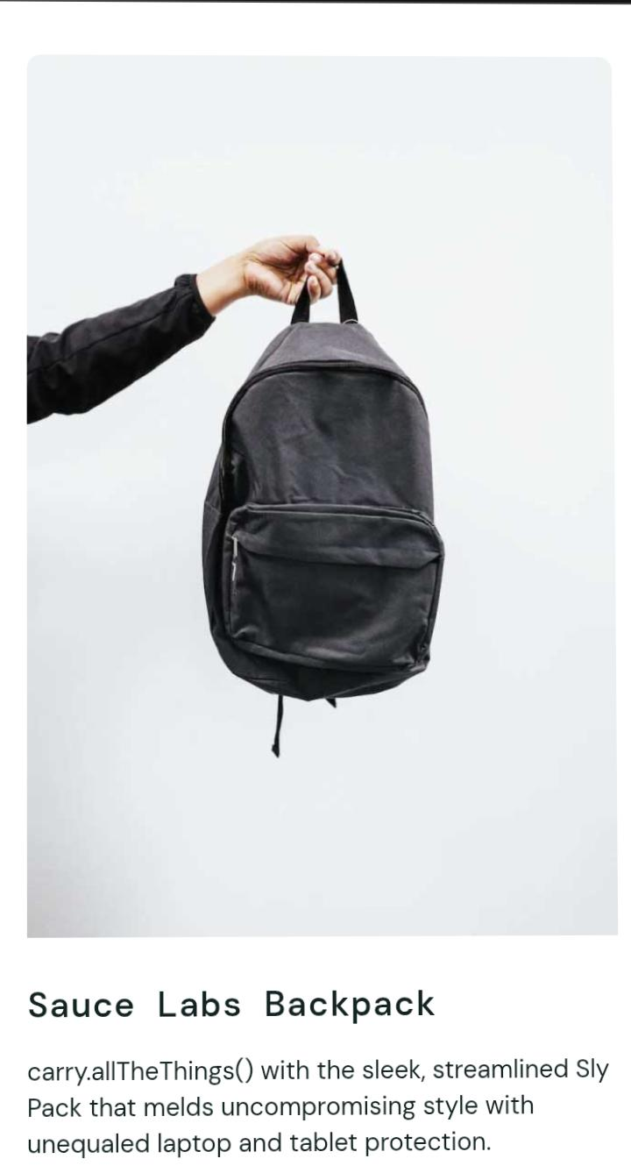
Expected Result: User should successfully log in and be redirected to the Products page.

TC002
Test Scenario: Login with invalid password
Test Steps:
- Open website.
- Enter valid username.
- Enter invalid password.
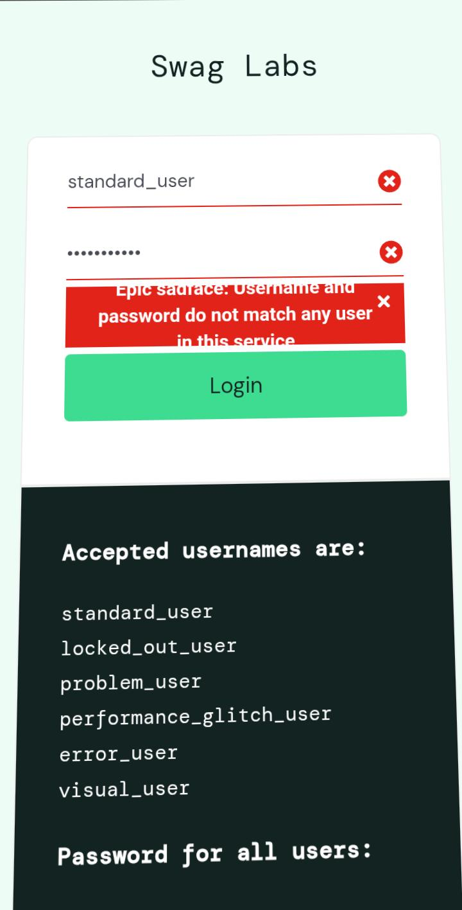
- Click Login.

Expected Result: Error message should be displayed.
TC003
Test Scenario: Login with invalid username
Test Steps:
- Open website.
- Enter invalid username.
- Enter valid password.
- Click Login.
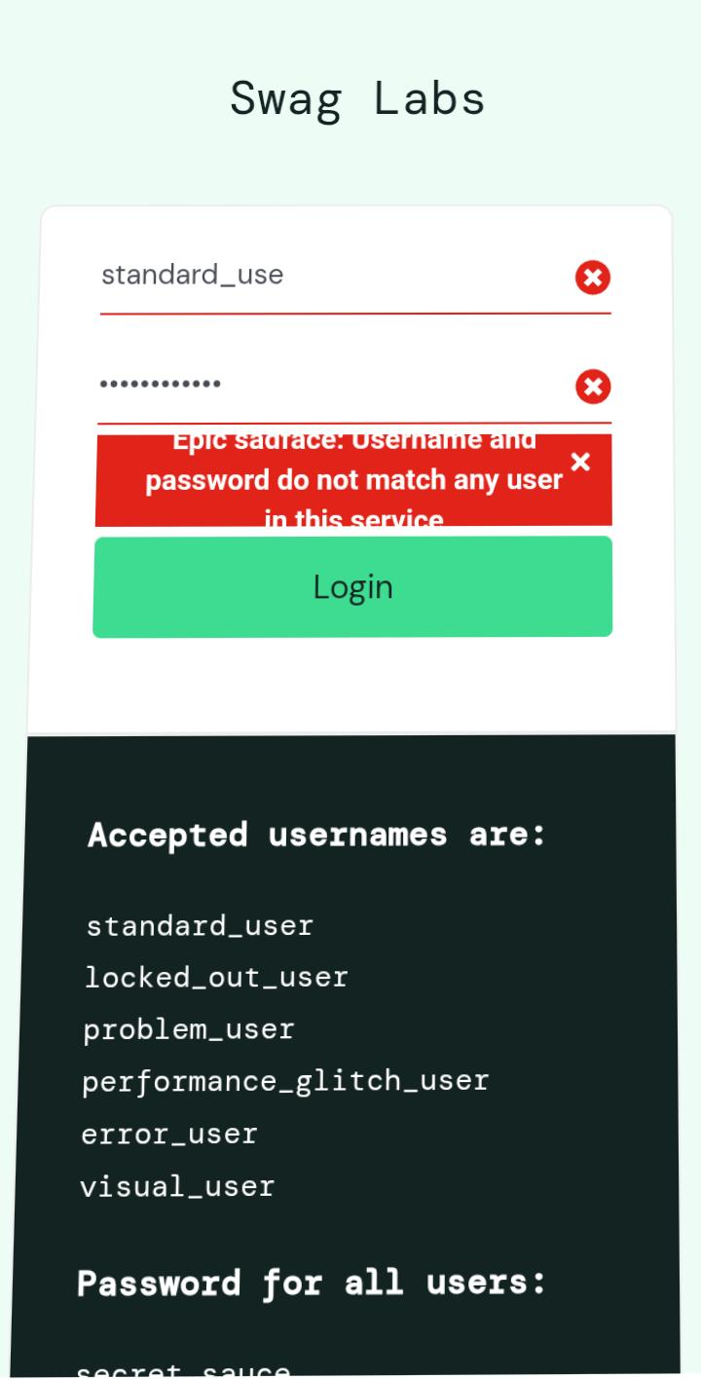
Expected Result: Error message should be displayed.
TC004
Test Scenario: Login with empty username field
Test Steps:
- Open website.
- Leave username blank.
- Enter password.
- Click Login.
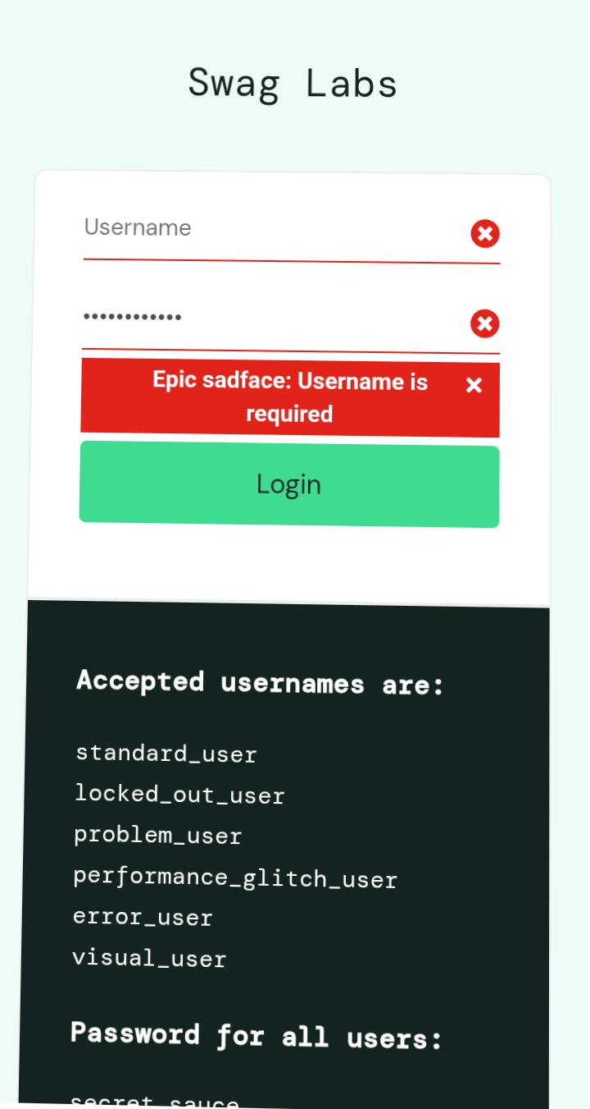
Expected Result: Username required message displayed.
TC005
Test Scenario: Login with empty password field
Test Steps:
- Open website.
- Enter username.
- Leave password blank.
- Click Login.

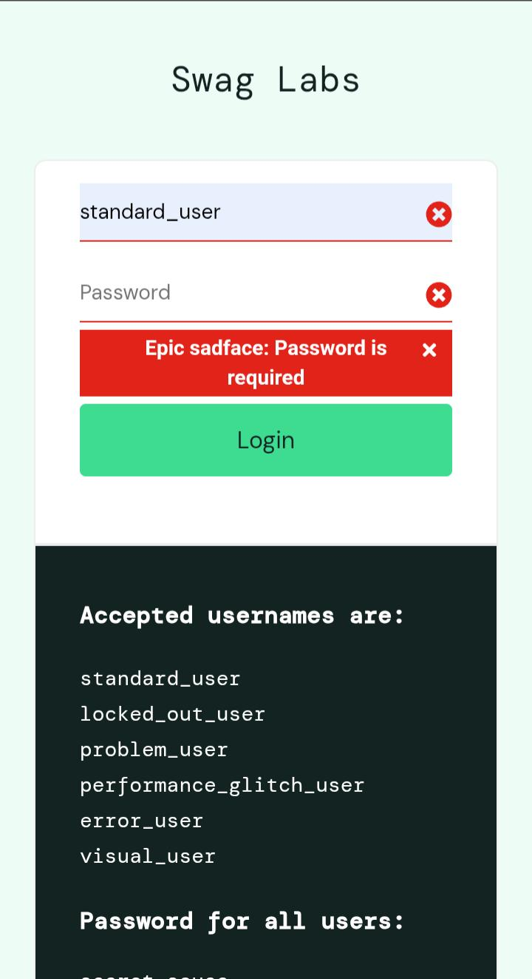
Expected Result: Password required message displayed.
TC006
Test Scenario: Login with both fields empty
Test Steps:
- Open website.
- Leave username blank.
- Leave password blank.
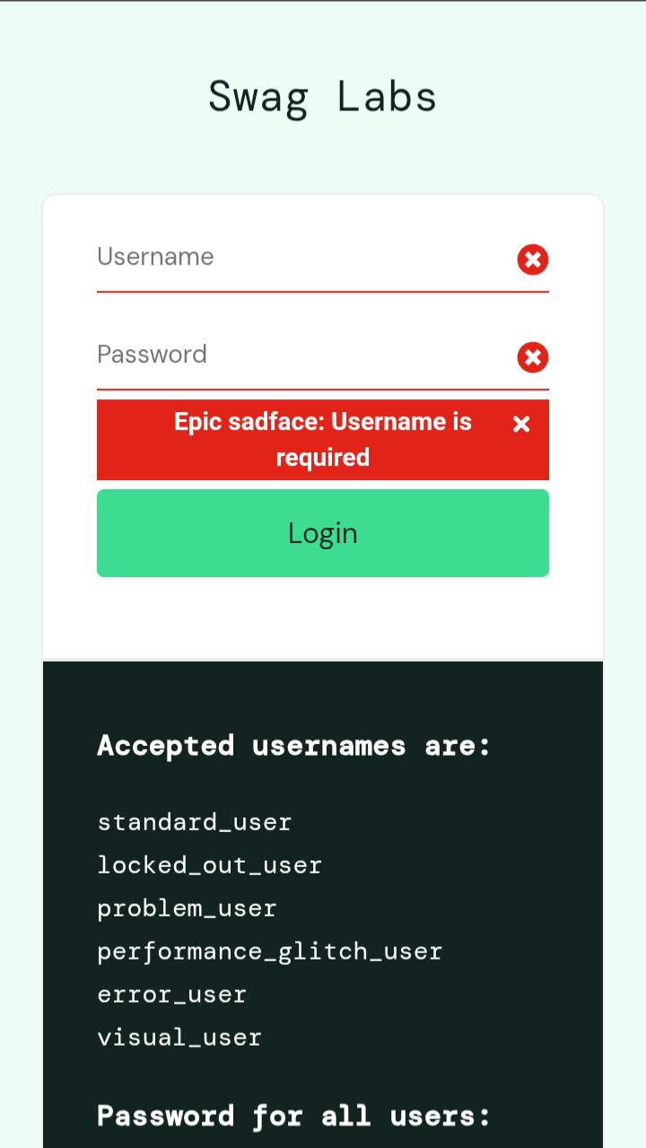
- Click Login.

Expected Result: Validation message displayed.
TC007
Test Scenario: Verify password field masking
Test Steps:
- Open website.
- Enter password.
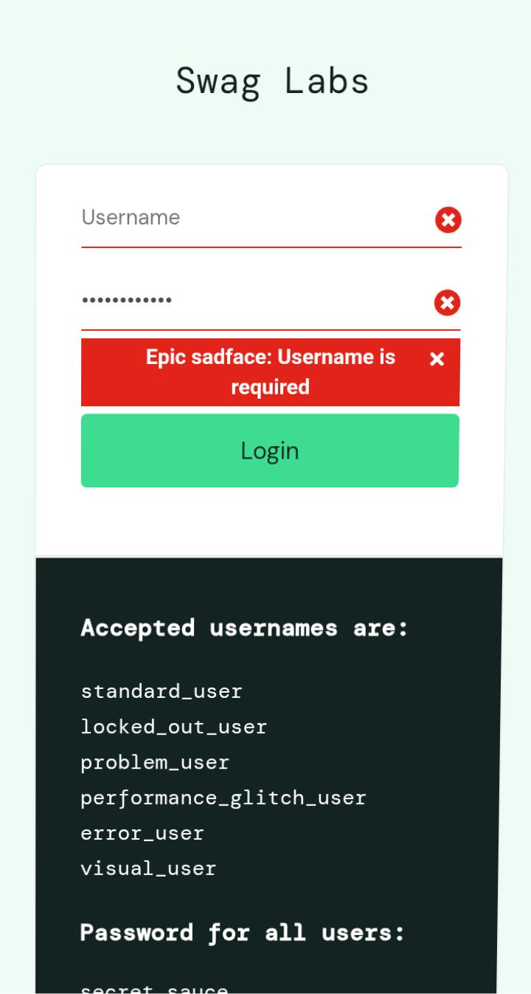
Expected Result: Password should be hidden with dots or asterisks.
TC008
Test Scenario: Login with locked-out user account
Test Steps:
- Enter locked-out user credentials.
- Click Login.
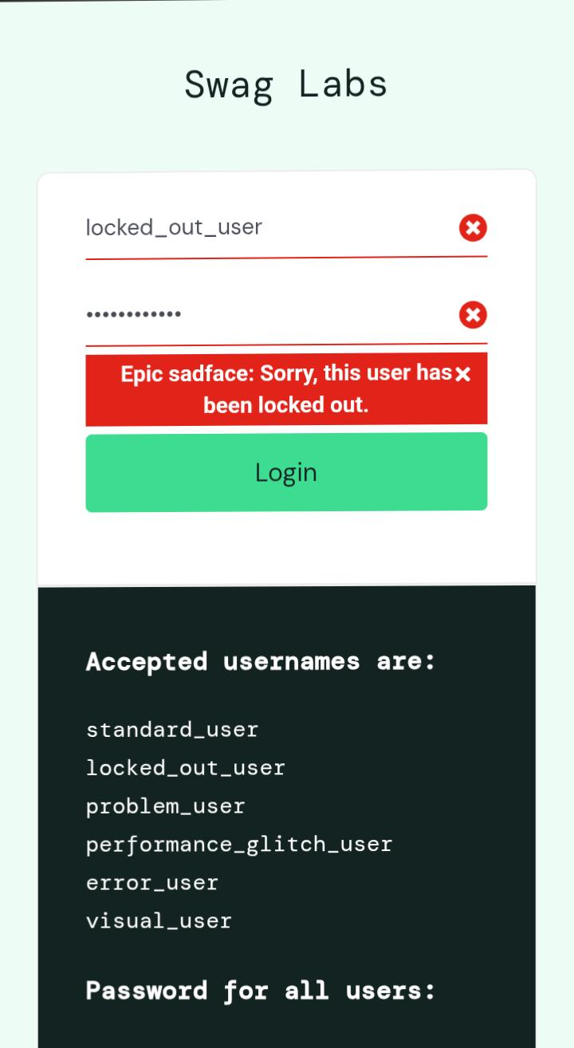

Expected Result: Access should be denied.
TC009
Test Scenario: Verify login button functionality
Test Steps:
- Enter valid credentials.
- Click Login button.
Expected Result: Button should trigger authentication process.
TC010
Test Scenario: Verify successful redirection
Test Steps:
- Login successfully.
Expected Result: User should be redirected to inventory page.
TEST EXECUTION RESULTS
Test Case | Actual Result | Status
TC001 | User logged in successfully | Pass
TC002 | Error message displayed | Pass
TC003 | Error message displayed | Pass
TC004 | Username required message displayed | Pass
TC005 | Password required message displayed | Pass
TC006 | Validation message displayed | Pass
TC007 | Password hidden successfully | Pass
TC008 | Access denied for locked user | Pass
TC009 | Login button worked correctly | Pass
TC010 | User redirected successfully | Pass

Summary:
Total Test Cases: 10
Passed: 10
Failed: 0
Pass Rate: 100%
BUG REPORTS
BUG ID: BUG001
Title: Generic error message displayed for invalid username and password
Severity: Low
Priority: Medium
Steps to Reproduce:
- Open login page.
- Enter incorrect username.
- Enter incorrect password.
- Click Login.
Expected Result: System should clearly indicate invalid credentials.
Actual Result: Generic error message displayed.
Status: Open
BUG ID: BUG002
Title: Error message remains visible after correcting credentials
Severity: Medium
Priority: Medium
Steps to Reproduce:
Enter invalid credentials.
- Click Login.
- Correct credentials.
- Attempt login again.
Expected Result: Previous error message should disappear automatically.
Actual Result: Error remains visible until page refresh.
Status: Open
BUG ID: BUG003
Title: Login page lacks password visibility toggle
Severity: Low
Priority: Low
Steps to Reproduce:
- Navigate to login page.
- Enter password.
Expected Result: User should have option to view entered password.
Actual Result: No password visibility option available.
Status: Open
CONCLUSION
The login module of the SauceDemo application was tested using manual testing techniques. Ten test cases were executed covering positive and negative scenarios. Most functionalities performed as expected. Three usability-related issues were documented as defects for further review. The project demonstrates practical application of Manual QA concepts including requirement analysis, test planning, test case design, test execution, and bug reporting.

